Bridgepoint Parts Catalog

Section IX: Valves Page 1

AH51

Ball Valve 3/8” F-F

AH53

Ball Valve 1/4” F-F

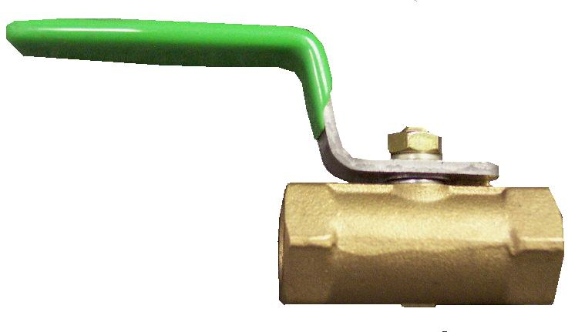
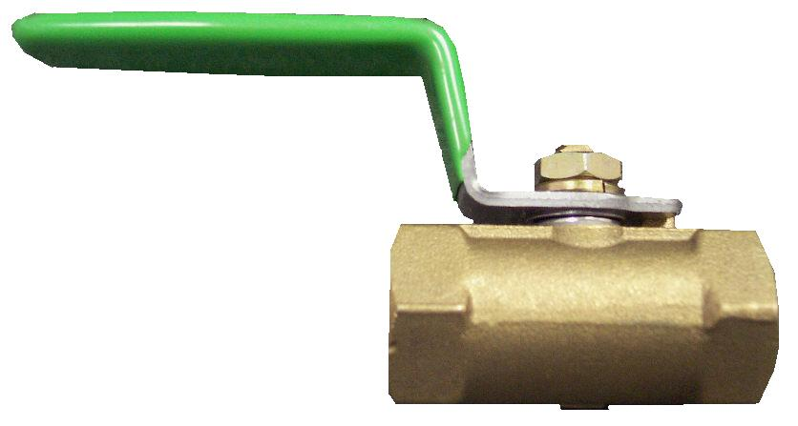

AH54B

Ball Valve 3/8” F-M

AH54

Ball Valve 1/4” F-M (450PSI)

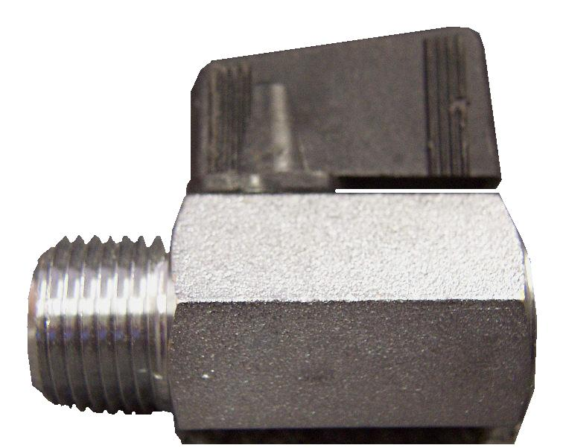
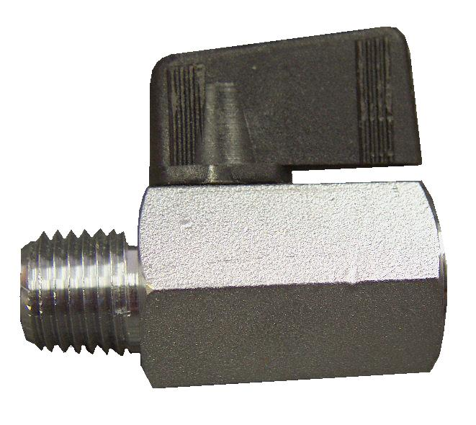

PHY169-018

Ball Valve 1/4” F-M

Brass
(White Magic part # B142)

AH56

Ball Valve 1/4” F-M

Economy (400PSI)

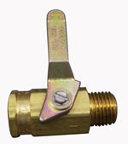
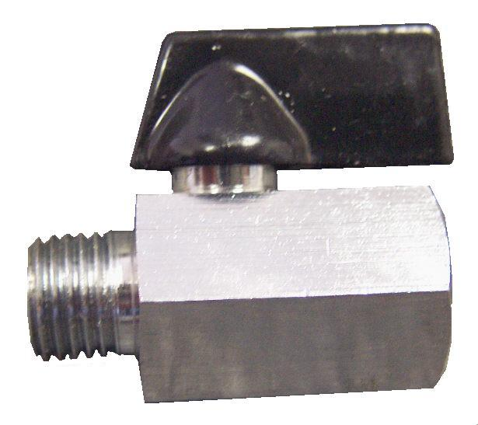

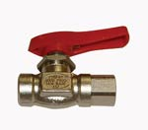

PP15-808012

Circle Seal Valve 1/4” F-F
Repair Parts:
New Style O-ring (Smaller): NA2320
New Style O-ring (Larger): NA2322
Old Style O-ring (Smaller): NA0814
Old Style O-ring (Larger): NA0837
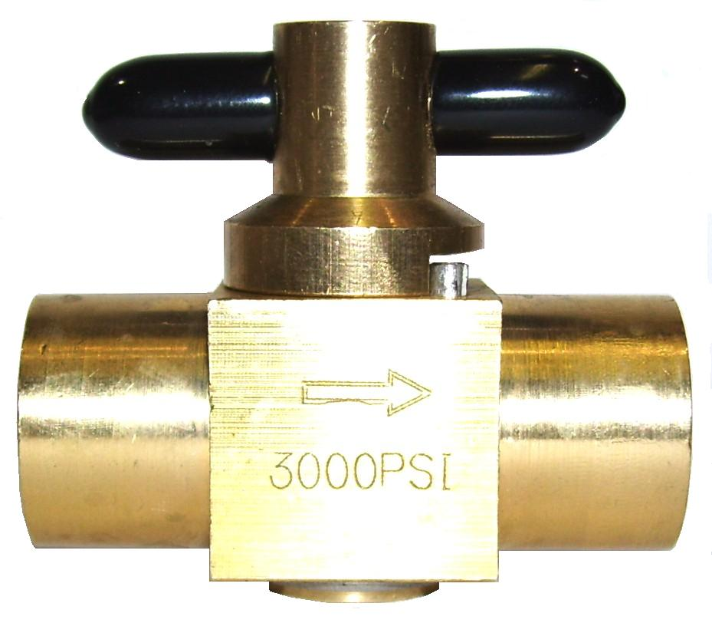

NEW

PP15-808169

Valve Chemical Pump Shutoff
Prochem: Performer 805 & Everest HP

PHY169-176

2 Way Valve 1/4” FPT

Chem Pump Shutoff

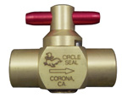

OLD

PWM-B147

Circle Seal Valve 1/4” F-M
Repair Parts:
O-ring (Smaller): NA0814
O-ring (Larger): NA0837

PP15-808060

3 Way Valve 1/2” FPT

PTO Temperature Control

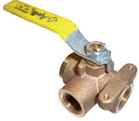
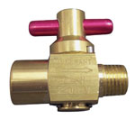

PHY169-1721

3 Way Valve 3/8” FPT

Salsa X Control Valve

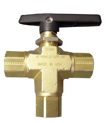

PP84192

Valve Ball 3-Way

Hi Temp / Pressure
Prochem: Everest & Everest HP
Temp Control & HP/LP Selector

PWM-B038

Ball Valve 1/2” F-F - Brass
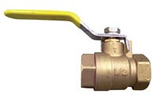

PR30-0360

Pressure Relief Valve – TES

50psi

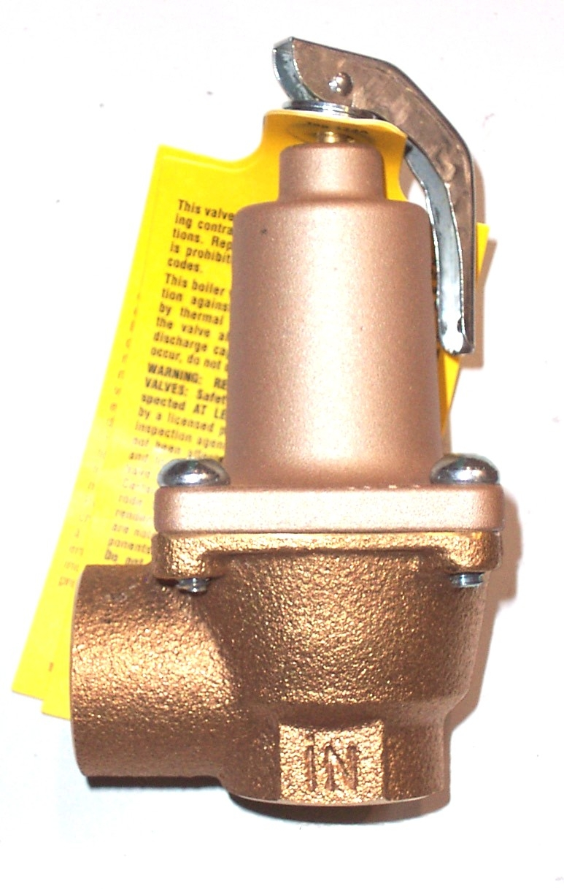

PWM-B0385

Ball Valve 1” F-F

Brass

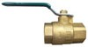

PWM-B135

Valve – Pop Off

Pressure Relief
3/8” MPT 1000-4000psi

PHY169-022

Ball Valve 1-1/2” FPT- Brass

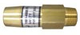
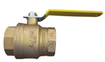

PHY169-005

CDS Heat Control Valve 5/8”

PHY169-085

CDS Heat Control Valve 3/4”
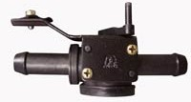
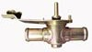

Bridgepoint Parts Catalog

Section IX: Valves Page 2

100011

Ball Valve 1-1/2” F-F

PVC - White

PEA11

Gate Valve 1-1/2” MPT

PVC – Black
Repair Parts:
45° Elbow: NM5079
Gasket: NM3019
Plastic Handle- Black: PCE120-07
Metal Handle – Cast: PA5112
Metal Handle – Machined: PP52-500093

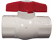
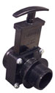

PWM-B145

Ball Valve 2” Duo Block

ABS 2” slip fitting or 2” FPT
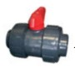

PALA14

Valve – Brine Tank
Water Softener AC40 & AC40B

PCE370-07

Gate Valve 1-1/2” FPT

PVC - Black
Repair Parts:
45° Elbow: NM5079
Gasket: NM3019
Plastic Handle- Black: PCE120-07
Metal Handle – Cast: PA5112
Metal Handle – Machined: PP52-500093
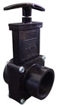

NM4212

Valve 3/4” Gate – Brass

TES By-pass Valve
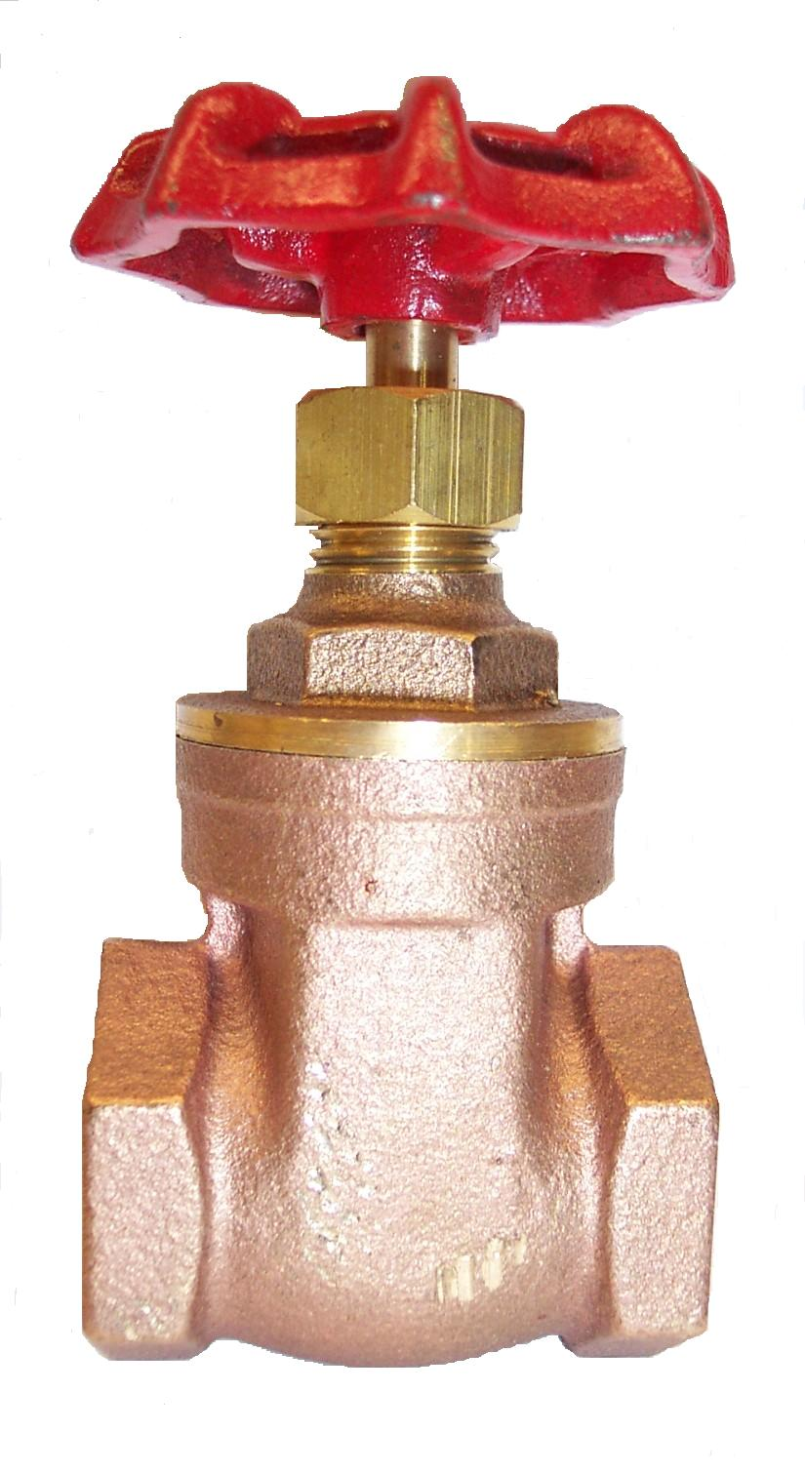

NM5728

Gate Valve 2” slip w/ Gatekeeper

PVC – Black
Gatekeeper: NM5728B

NM5096

Priming Valve – HP Pumps

Olympus Portables
Valve: NA0845
Repair Kit: NA0842
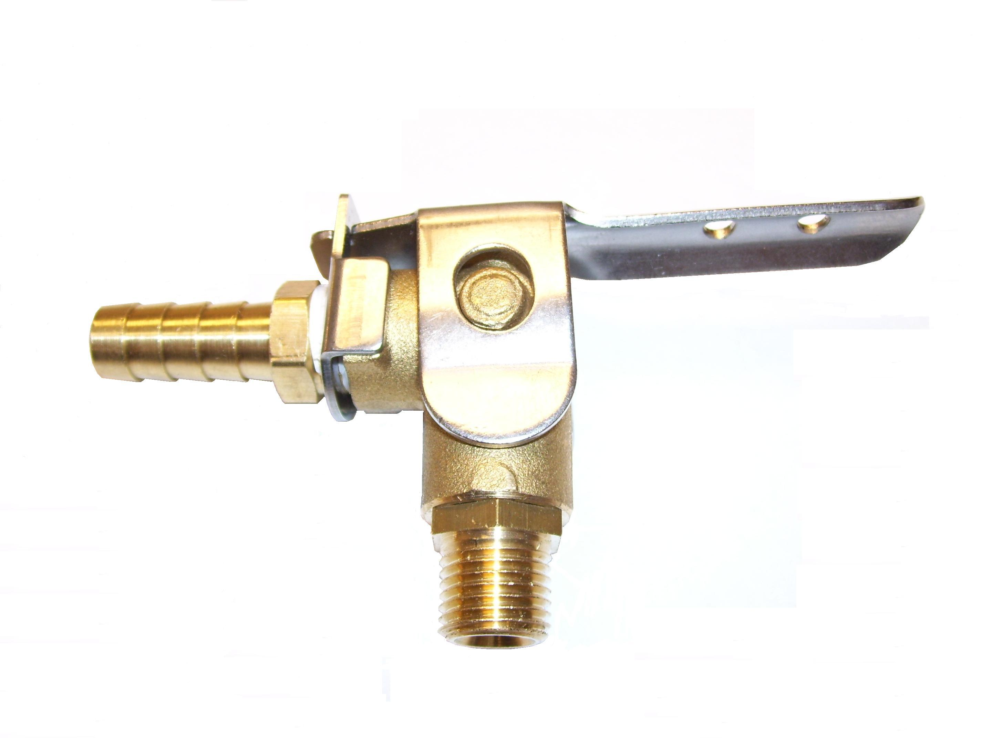

NA0875

Check Valve Assembly

1/8” VeeJet –
Stubby Strainer: NA0876
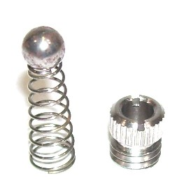

PBL23025

Float Valve – Water Box
Blueline Truckmounts
Repair Parts:
Seat: PBL48006
Float: PP19-807014

PHY169-218

Float Valve – Water Box
Hydramaster: All machines with Last Step Chemical Injection. Replaces old style float valve PHY169-167.

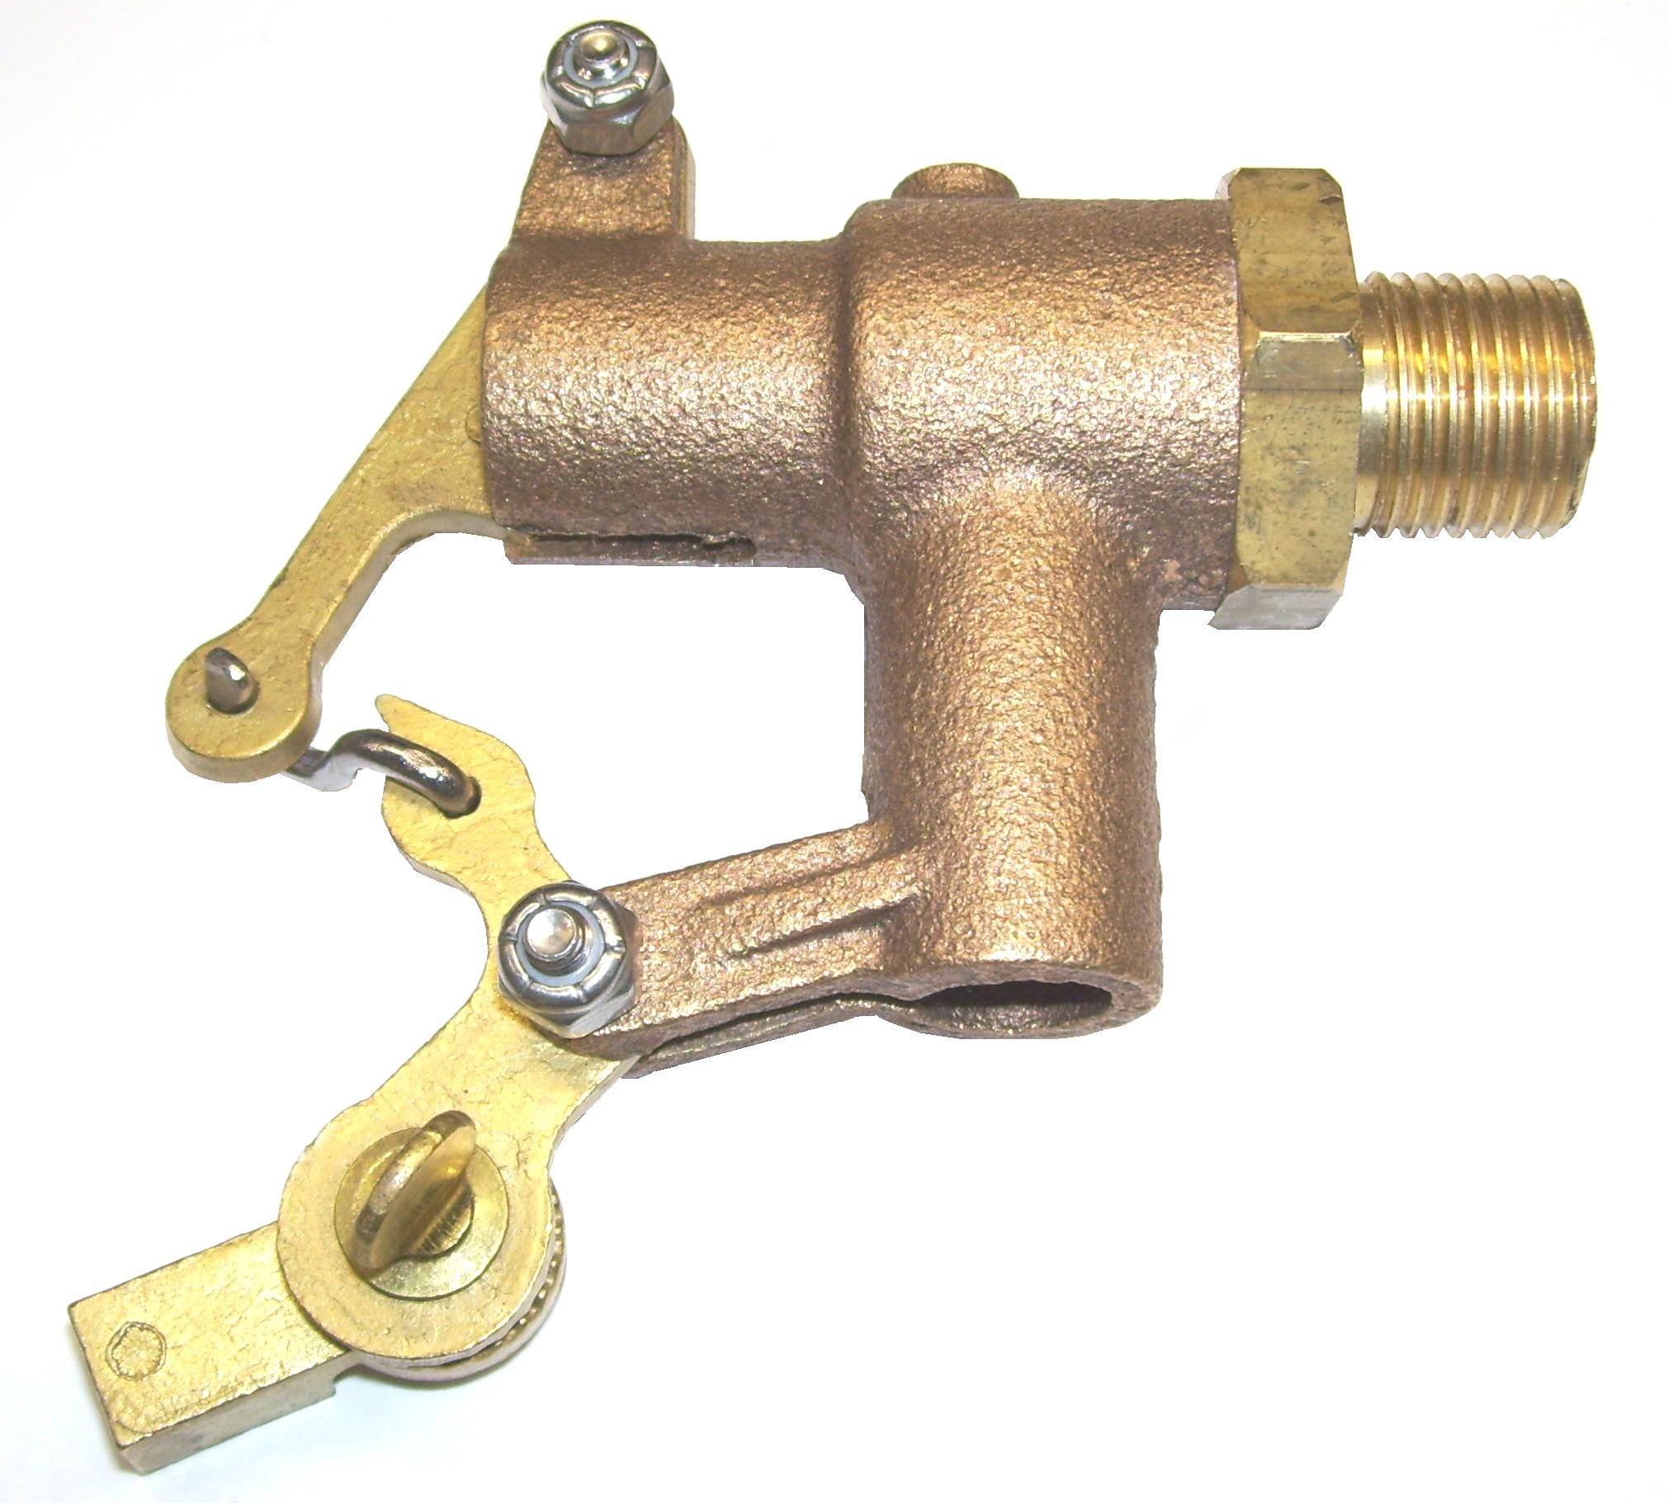
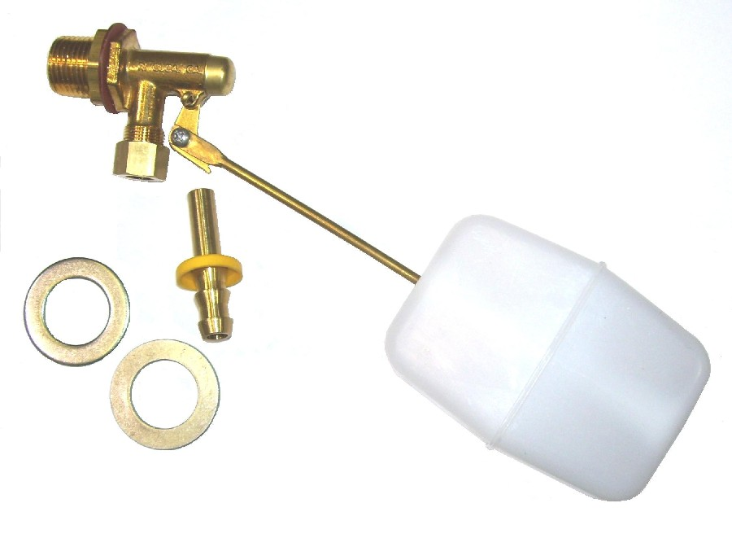

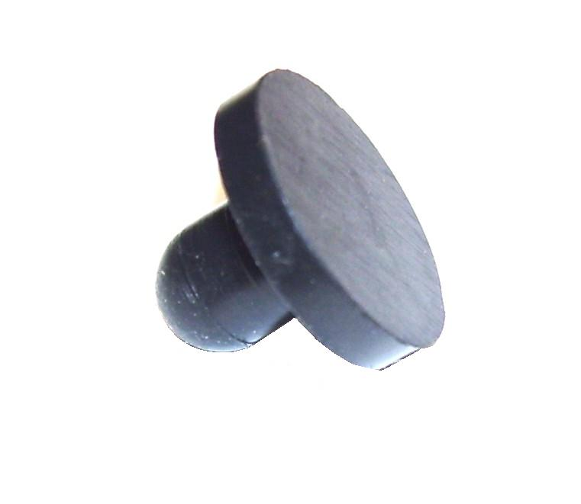

PBL69198

Float Valve Assembly- Sapphire TM’s

TEMP STOCK

PBL23030

Thermal By-pass Valve 180˚F
1/2” FPT - Brass

PBL28007

Ball Oblong - Float Valve - Sapphire TM’s

TEMP STOCK

PBL23044

Temperature Control Valve
1/2” FPT - Brass

NM5822

Hudson Water Control Valve

1/2” FPT

Hydro Well II

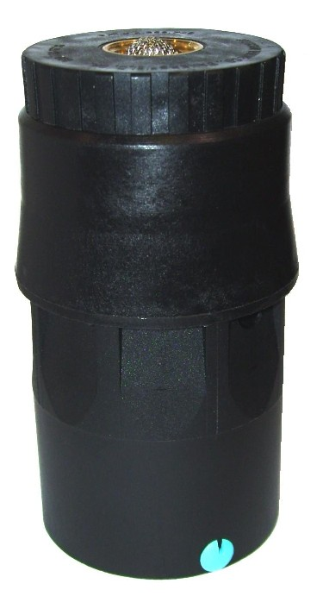

PHY169-195

Valve – Pop Off

Pressure Relief 120PSI
Chem Dry TM

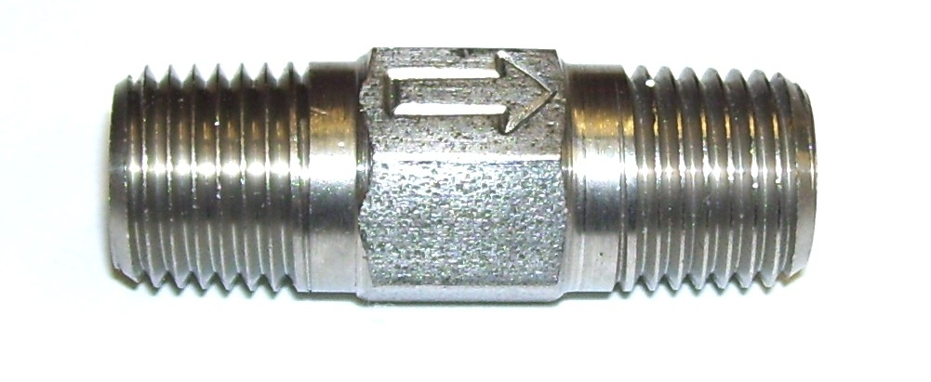

PM751020

Float Valve Assembly

Hydro Well

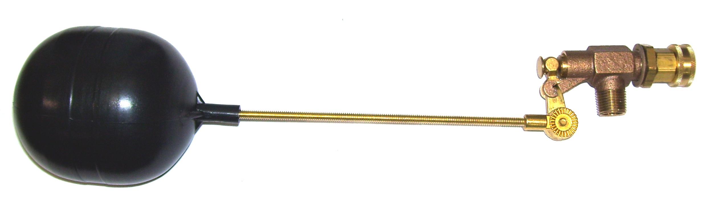

Bridgepoint Parts Catalog

Section IX: Valves Page 3

PP15-808106

Chemical Metering Valve

1/8” FPT

PP15-808028

Chemical Metering Valve

1/8” FPT
(White Magic part # B086)
(Hydramaster part # 169-160)

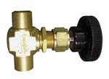
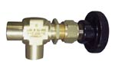

NM3005

3 Way Valve 1/8” FPT

Chemical Prime Valve
(Prochem part # 15-808022)
(White Magic part # B085)

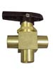

PP15-808087

Temperature By-pass Valve

1/8” FPT
(Prochem part # 15-808107)
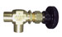

PP42-809028

Valve Stem Assembly

Pulsation Dampener
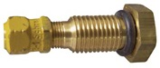

PHY169-017

3 Way Valve 1/8” FPT

Chemical Prime Valve

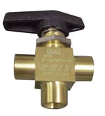

NM5055

Float Valve Assembly

With Chemical Metering New Style

Olympus Auto-Fill
Metering Tip Kit: PDE001
Chain w/connector: PDE34-17
Float: PHY005-003
Filter / Check Valve: PDE100-11P
Proportioner: PDE61-22-3
Valve Repair Kit: PDE63-87
Float Hanger Wire: PDE35-42
Float Hanger Clip: PDE35-12

PP42-809274

Valve Stem Assembly

Accumulator

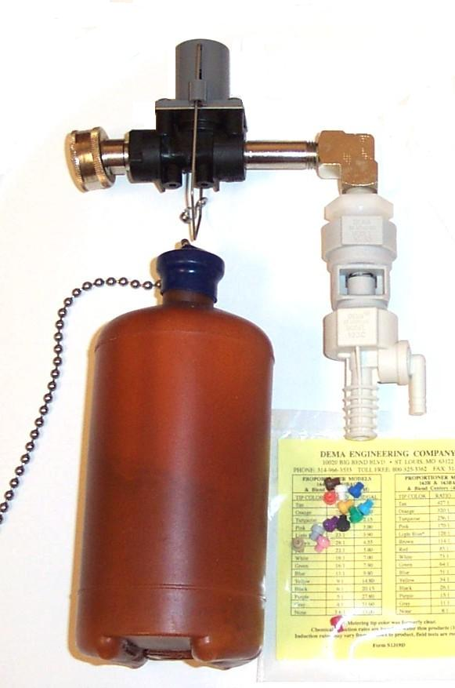
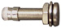

Parts for Old Style Float Valve Assembly - Olympus Auto-Fill

With Chemical Metering
Metering Tip Kit: PDE001
Float: PHY005-003
Chain w/connector: PDE34-17
Diaphragm: PDE34-3
Pilot Valve Assy: PDE34-24
Valve Cover: PDE003
O-ring Valve Cover: PDE34-4
Filter / Check Valve: PDE100-11P
Proportioner: PDE61-22-3

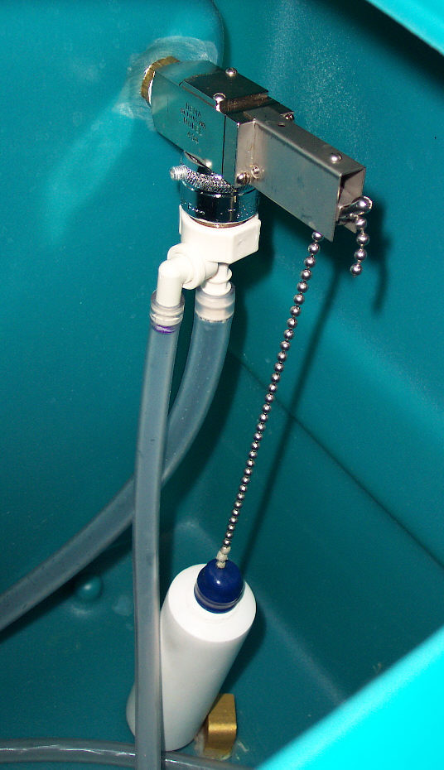

PP15-808086

Float Valve 1/2”FPT

With float assembly

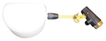

PHY169-167

Float Valve – Water Box
Hydramaster: Maxx 450D, Maxx470D, Boxxer 421 &
Boxxer 427 – Newer CDS 4.6 & 4.8 with Last Step Chemical Injection
Bridgepoint: Javelin
Repair Parts:
Seat Kit: PHY078-375
Float: PHY005-007

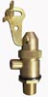

PP15-808097

Float Valve 1/2” MPT

Brass – without float assembly
(White Magic part # A026)
Repair Parts:
Seat: PP16-808227
Float: PP19-807014
Rod (Stainless Steel): PP54-501715
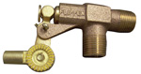

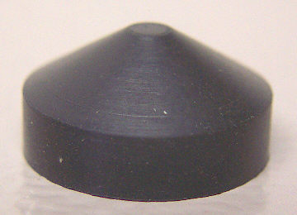
DISCONTINUED

SEE: PHY169-218

PP66-945179

Kit Float Valve Assembly

PP15-808110 – with float
Used on Plastic Water Box
Repair Parts:
Seat: PP16-808164

PP15-808110

Float Valve

Brass – without float assembly
Used on Plastic Water Box
Repair Parts:
Seat: PP16-808164
Float: PP19-807014
Rod (Stainless Steel): PP54-501715

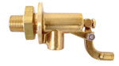
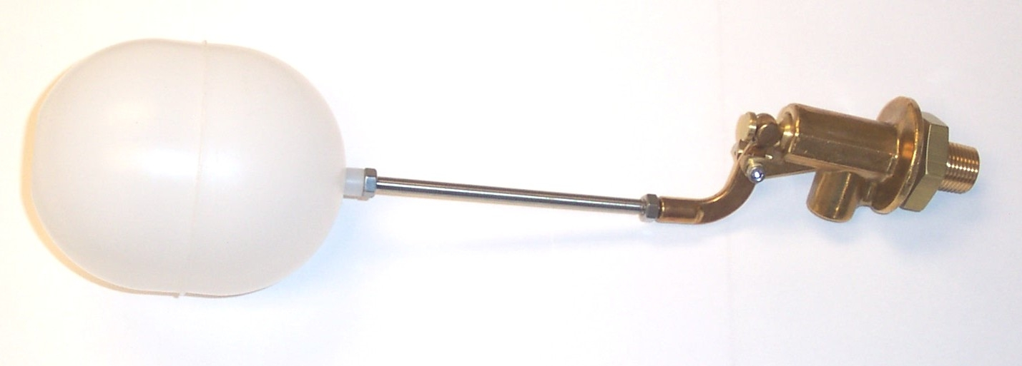

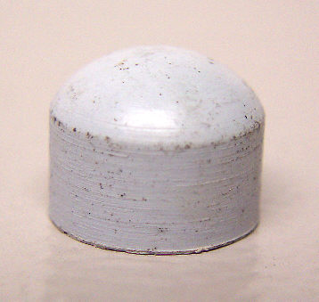

PP15-808095

Check Valve Manifold Assy. with Check Valve and Filter

Prochem: Bear, Bruin, Bruin II, Performer, Performer 405, Legend, Legend SE, & Trailblazer.
Bridgepoint: Lancer & Saber
Components:
Manifold: PP52-501621
Check Valve Assy.: PP15-808094
Filter: PP14-806549

Bridgepoint Parts Catalog

Section IX: Valves Page 4

PP42-809265

Check Valve – Chemical Pump

with O-Ring
(White Magic part #AP005-P) (Hydramaster part # 169-155)
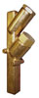
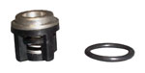

NM5052

Check Valve – 3/4” FPT
Brass – Swing Gate Valve
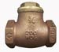

PP15-808077

Check Valve – 1/2” FPT

Brass – Swing Gate Valve

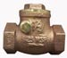

PP15-808094

Check Valve Assembly
Prochem: All machines with check valve manifold assembly.
Bridgepoint: Lancer, Saber & System IV.
Repair Parts:
O-Ring - Seat: PP43-810008
O-Ring – Cap: PP43-810079
Seat: (SS) PP16-808223
Spring: PP16-808224
Poppet: PP16-808226
Insert: (Teflon) PP16-808225

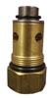

PP15-808032

Check Valve – 1/2” FPT - Brass
(Prochem part # 15-808151)

Prochem: Old style outlet check valve before use of outlet manifold assembly. Cub, CubXL, 800A, 100A, 150 & Oil Fired TM
Repair Parts:
Valve Assembly: PP15-808100
O-Ring - Seat: PP43-810008
O-Ring – Cap: PP43-810079
Seat: (SS) PP16-808223
Spring: PP16-808224
Poppet: PP16-808226
Insert: (Teflon) PP16-808225
1/8” Brass Plug BR220
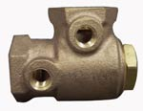
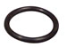
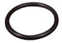

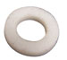

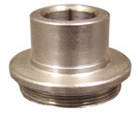
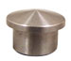

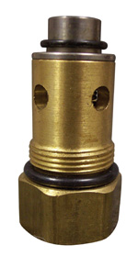
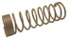

PP15-808027

Check Valve – Differential

Brass - 1/2” FPT

Prochem: 100A, 150 & Oil Fired TM
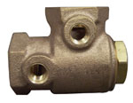

PHY169-062

Valve – Anti Siphon 1/4”
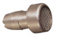

PHY169-061

Valve – Anti Siphon 3/8”
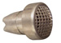

PHY169-175

Check Valve 3/8” F-F 65PSI

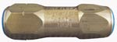

PHY169-236

Check Valve 3/8” F-F 80PSI

Re-buildable
Repair Kit: PHY078-916

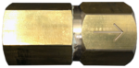
DISCONTINUED USE PHY169-236

PHY169-186

Check Valve 3/8” F-F 100PSI

PWM-B221

Check Valve 1/4” F-F Brass
White Magic: Chemical Check Valve on all machines

DISCONTINUED USE PHY169-236

PHY169-219

Check Valve 3/8” F-F 80PSI

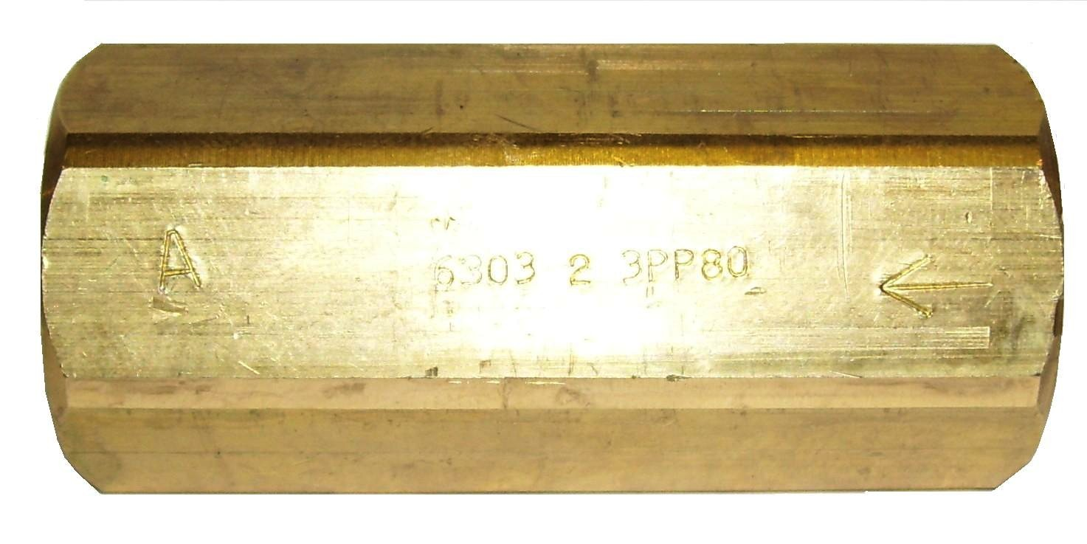

PHY169-025

Check Valve 1/4”

Stainless Steel
Hydramaster: Chemical feed check
valve on old style Hydracat without mix tank.
DISCONTINUED USE PHY169-236
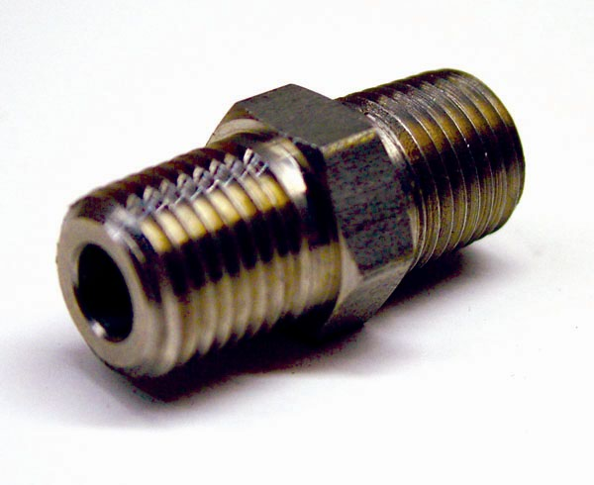

PP15-808030

Check Valve 1/8” F-M – Brass
Old Style Chemical Pump
Prochem: 100A & 150

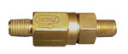

Bridgepoint Parts Catalog

Section IX: Valves Page 5

PSA100901

Pressure Relief Valve 175PSI

Power X Spotter w/Heat

